CHAPTER 1

INTRODUCTION

Osteoporosis is a prevalent bone disease characterized by decreased bone density and deterioration of bone tissue, leading to fragile bones and an increased risk of fractures. While it is commonly associated with aging, other factors such as genetics, lifestyle, and hormonal changes can also contribute to its onset. Early detection and diagnosis of osteoporosis are crucial for preventing severe complications and managing the condition effectively.
Traditionally, osteoporosis is diagnosed using methods like bone mineral density (BMD) tests, such as Dual-Energy X-ray Absorptiometry (DEXA). However, these methods can be costly, less accessible, and inconvenient for widespread screening. To address these challenges, advancements in machine learning and medical imaging have opened new pathways for automating the detection of osteoporosis using simpler and more accessible imaging techniques like X-rays.
This project focuses on detecting osteoporosis by analyzing knee X-ray images. The knee joint is a critical area where bone changes due to osteoporosis can manifest visibly. By leveraging machine learning algorithms, the project aims to develop an efficient and automated system for analyzing knee X-rays to identify early signs of osteoporosis.
Machine learning algorithms, such as Convolutional Neural Networks (CNNs), are well-suited for image analysis tasks. These models can learn patterns from labeled datasets of X-ray images to differentiate between healthy and osteoporotic bones. In this project, preprocessing techniques like image augmentation, normalization, and feature extraction will be applied to enhance the accuracy and reliability of the machine learning models.
The proposed system has the potential to offer a cost-effective, non-invasive, and rapid diagnostic tool for healthcare providers. This can help in identifying at-risk individuals, promoting early intervention, and reducing the overall burden of osteoporosis on the healthcare system.
The report will outline the methodology, including data preprocessing, machine learning model selection, training, and evaluation. It will also discuss the challenges, limitations, and potential future enhancements for improving the system's accuracy and applicability in real-world settings.

CHAPTER 2

PROBLEM DEFINITION

Osteoporosis is a silent disease that progresses without obvious symptoms until a fracture occurs, often resulting in significant health, economic, and societal burdens. Current diagnostic methods, such as Dual-Energy X-ray Absorptiometry (DEXA), are effective but are not widely accessible due to their cost, limited availability, and dependency on specialized equipment. These limitations make early detection and widespread screening of osteoporosis challenging, particularly in resource-constrained environments.
The problem lies in the lack of affordable, non-invasive, and scalable diagnostic tools that can identify osteoporosis at an early stage. Knee X-rays, which are more commonly available and cost-effective than DEXA scans, present an opportunity for leveraging machine learning technologies to fill this diagnostic gap. However, traditional analysis of X-ray images requires expert interpretation, which may not always be feasible or consistent in all clinical settings.
This project addresses the following challenges:
- Automated Analysis: Developing a machine learning-based system capable of analyzing knee X-rays to detect signs of osteoporosis, reducing the dependency on manual interpretation by medical experts.
- Cost-Effectiveness: Providing a low-cost diagnostic alternative that can be deployed in remote or underserved regions.
- Scalability: Creating a solution that can handle large-scale screening initiatives without compromising accuracy or efficiency.
- Early Detection: Enabling the identification of osteoporosis in its early stages to facilitate timely medical intervention and reduce the risk of fractures.
By designing a machine learning model that can accurately and efficiently detect osteoporosis using knee X-ray images, this project aims to bridge the gap between diagnostic accessibility and affordability, ultimately improving patient outcomes and quality of life.

CHAPTER 3

LITERATURE REVIEW

• Prevalence of Osteoporosis: Studies indicate that osteoporosis is a major public health issue, particularly among the aging population. Fractures associated with this condition significantly affect the quality of life and pose an economic burden.
• Limitations of Current Diagnostic Methods: Research highlights the high cost and limited accessibility of DEXA scans, the gold standard for diagnosing osteoporosis, making alternative diagnostic tools essential.
• Role of Radiographic Imaging: Knee X-rays are frequently used in clinical settings for assessing joint conditions. Studies suggest these images could also reveal changes indicative of bone density loss.
• Machine Learning in Medical Imaging: Literature emphasizes the increasing adoption of machine learning algorithms, such as Convolutional Neural Networks (CNNs), for analyzing medical images to detect diseases with high accuracy.
• Feature Extraction in Bone Analysis: Previous studies have explored techniques for extracting structural and texture features from X-ray images to evaluate bone health and detect abnormalities.
• Applications of Deep Learning: Research shows that deep learning models can outperform traditional methods by automatically identifying patterns and features in X-ray images without requiring manual feature extraction.
• Importance of Early Detection: Multiple studies underline the need for early detection of osteoporosis to prevent fractures, which are often the first visible symptoms of the disease.
• Bone Quality Indicators in X-rays: Literature reveals that cortical thickness, trabecular patterns, and overall bone morphology observable in X-rays are reliable indicators of bone density and quality.
• Use of Transfer Learning: Studies demonstrate the effectiveness of transfer learning, where pre-trained models on large datasets are fine-tuned for specific tasks like osteoporosis detection using smaller datasets.
• Challenges in X-ray Image Processing: Literature discusses challenges such as image noise, variations in imaging conditions, and overlapping anatomical structures that can affect model performance.
• Comparison of Algorithms: Research compares different machine learning algorithms, such as Support Vector Machines (SVM), Random Forests, and CNNs, highlighting CNNs as the most promising for image-based diagnostics.
• Integration of AI in Healthcare: Studies highlight the potential of AI to assist clinicians in making faster, more consistent, and accurate diagnoses, reducing the workload in resource-limited settings.
• Validation of Models: Literature emphasizes the importance of validating models on diverse datasets to ensure robustness and generalizability across different populations and imaging conditions.
• Ethical and Regulatory Considerations: Research addresses ethical issues surrounding AI in healthcare, such as patient privacy, data security, and the need for regulatory compliance.
• Potential for Deployment in Resource-Limited Areas: Studies suggest that AI-driven tools, combined with widely available imaging techniques like X-rays, can democratize access to osteoporosis screening and diagnosis.

CHAPTER 4

PROJECT DESCRIPTION
Osteoporosis is a progressive bone disease characterized by reduced bone density and quality, increasing the risk of fractures. Early detection is crucial for preventing severe complications, but existing diagnostic tools like DEXA scans are often inaccessible due to high costs and limited availability. This project aims to develop a machine learning-based system that analyzes knee X-ray images to detect signs of osteoporosis effectively and affordably.
The project focuses on leveraging advanced image processing and machine learning techniques to identify structural changes in bones, such as cortical thinning and trabecular deterioration, that are indicative of osteoporosis. The system will process knee X-ray images, extract key features, and classify the bone condition as normal or osteoporotic. By using algorithms such as Convolutional Neural Networks (CNNs) and transfer learning, the project seeks to achieve high accuracy and reliability in detecting osteoporosis.
The proposed solution offers several benefits, including cost-effectiveness, accessibility, and rapid diagnostics. It is designed to aid healthcare professionals, especially in resource-limited areas, by providing a pre-screening tool that complements traditional diagnostic methods. The ultimate goal is to improve early detection rates, enabling timely treatment and reducing the overall burden of osteoporosis on individuals and healthcare systems.
Key deliverables of the project include:
- A dataset of labeled knee X-ray images.
- A machine learning model trained and validated for osteoporosis detection.
- A user-friendly interface for uploading and analyzing X-ray images.

CHAPTER 5

REQUIREMENTS

The requirements for this project can be categorized into functional requirements, non-functional requirements, and system requirements. Below is a brief explanation of each category:

Functional Requirements
These define the core functionalities that the system must provide:

- Input Image Processing: The system must accept knee X-ray images as input.
- Feature Extraction: The system should analyze the images to extract critical features like cortical thickness and trabecular patterns.
- Classification: A machine learning model will classify the images into categories such as "normal" or "osteoporotic."
- Accuracy and Prediction: The system must provide accurate results with clear prediction labels and probability scores.
- Result Display: Display the classification results on a user-friendly interface, along with an explanation of the findings.
- Data Storage: Save the input images and classification results for future reference and analysis.
- Model Retraining: Allow for periodic updates and retraining of the model with new data to improve accuracy.

Non-Functional Requirements
These define the quality attributes of the system:

- Scalability: The system should handle multiple image inputs simultaneously without performance degradation.
- Performance: Predictions should be generated within a few seconds of submitting an X-ray image.
- User-Friendly Interface: The interface should be simple and intuitive for healthcare professionals.
- Cost-Effectiveness: The solution should use accessible hardware and open-source software tools to minimize costs.
- Security and Privacy: Protect sensitive patient data and adhere to medical data regulations (e.g., HIPAA compliance).
- Portability: The system should be deployable across various devices (desktop, cloud-based, or mobile applications).

System Requirements

These outline the hardware and software resources needed for implementation:
- Hardware Requirements:
  - A workstation or server with a GPU for training the machine learning model.
  - Minimum specifications: 16 GB RAM, 1 TB storage, and a compatible graphics card (e.g., NVIDIA).
  - An X-ray imaging device for generating input data (if required).
- Software Requirements:
  - Programming languages: Python for development and implementation.
  - Libraries and frameworks: TensorFlow/Keras, PyTorch (for deep learning), OpenCV (for image processing), and NumPy.
  - Tools: Jupyter Notebook or PyCharm for coding and debugging.
  - Database: MySQL or MongoDB for storing image metadata and classification results.
  - Operating System: Windows/Linux/MacOS (for development and deployment).
- Dataset Requirements:
  - A large, labeled dataset of knee X-ray images annotated with corresponding osteoporosis classifications. Datasets can be obtained from public sources like MURA or curated through collaborations with healthcare institutions.

CHAPTER 6

METHODOLOGY

The methodology section of the project outlines the entire process of detecting osteoporosis using knee X-rays, from data collection to model deployment. Below is a detailed explanation of the methodology:
1. Data Collection and Preprocessing
- Data Source: The project uses knee X-ray images collected from a medical database or hospitals. These X-rays are labeled as either showing signs of osteoporosis or being healthy (control images).
- Preprocessing: To make the images ready for analysis and improve the accuracy of the model, preprocessing techniques are applied:
  - Image Resizing: All X-ray images are resized to a consistent dimension to maintain uniformity.
  - Normalization: Pixel values are normalized to a range (e.g., 0 to 1) to standardize the input data for the machine learning model.
  - Noise Reduction: Techniques like Gaussian blur or median filtering may be applied to reduce image noise, improving the clarity of features in the X-ray images.
  - Augmentation: To increase the size of the training dataset, image augmentation techniques like rotation, flipping, and cropping are applied. This helps in improving the model’s generalization capability.
2. Feature Extraction
- Image Feature Extraction: Before feeding the images into the machine learning model, it’s important to extract useful features. This can be done using image processing techniques:
  - Edge Detection: Algorithms like the Canny edge detector or Sobel operator are used to highlight edges in the X-ray images, which can help identify regions of interest related to bone density and structure.
  - Texture Analysis: Techniques like Local Binary Patterns (LBP) or Gabor filters are used to extract texture features that could indicate changes in bone structure, which are essential in detecting osteoporosis.
  - Region of Interest (ROI): The specific area of the knee joint is selected to focus the model on the most relevant features, improving the accuracy and reducing the complexity.
3. Model Selection
- Machine Learning Algorithms: Various machine learning techniques are evaluated to choose the most effective method for osteoporosis detection. Some popular choices include:
  - Support Vector Machines (SVM): SVM is a powerful classifier that works well for binary classification tasks. It attempts to find the hyperplane that best separates the two classes (osteoporotic vs. healthy).
  - Convolutional Neural Networks (CNNs): CNNs are widely used for image analysis due to their ability to automatically extract features from raw images. They consist of convolutional layers that detect spatial hierarchies in the image data.
  - Random Forest: A random forest classifier consists of multiple decision trees and can handle complex datasets well. It is robust to overfitting and works well with high-dimensional features.
- Model Training: The selected model is trained on a labeled dataset. During the training phase, the model learns the distinguishing patterns between the healthy and osteoporotic knee X-rays based on the extracted features.
  - Cross-Validation: To ensure that the model generalizes well to unseen data, techniques like k-fold cross-validation are applied. This involves splitting the dataset into k subsets and training the model k times, each time with a different training and validation set.
4. Model Evaluation
- After training the model, it is important to evaluate its performance using a separate test set that the model has not seen before. The evaluation metrics typically include:
  - Accuracy: Measures the overall percentage of correct predictions.
  - Precision: Indicates how many of the positive predictions were actually correct (important for minimizing false positives).
  - Recall: Shows how many of the actual positive instances were correctly identified by the model (important for minimizing false negatives).
  - F1 Score: The harmonic mean of precision and recall, providing a single metric for the model's performance.
- Confusion Matrix: A confusion matrix is used to summarize the performance of the classification model, showing the true positives, true negatives, false positives, and false negatives.
5. Deployment and Application
- System Integration: The trained model is integrated into a healthcare system where medical professionals can upload knee X-ray images for real-time analysis. This system could be a web or mobile application.
- Real-time Analysis: The system processes incoming X-ray images, extracts features, and feeds them into the trained model to classify the image as either showing osteoporosis or being healthy.
- User Interface: A user-friendly interface is developed to display results to healthcare professionals. It may include visualizations like heatmaps or highlighted regions on the X-ray to show the areas where osteoporosis is detected.
- Model Updates: Over time, as more knee X-rays are collected, the model can be retrained to improve its accuracy and adapt to new data.
6. Challenges and Solutions
- Imbalanced Dataset: In medical imaging, datasets often have more healthy images than osteoporotic ones. Techniques like oversampling, undersampling, or using synthetic data (e.g., SMOTE) are employed to handle this imbalance.
- Interpretability: Since medical applications require trust and transparency, model interpretability techniques like Grad-CAM or LIME are used to show which areas of the image contributed to the decision, improving the trustworthiness of the model in a clinical setting.

CHAPTER 6

METHODOLOGY

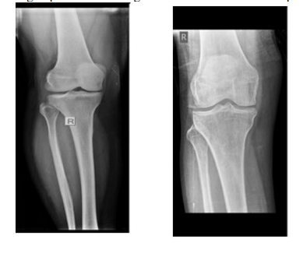

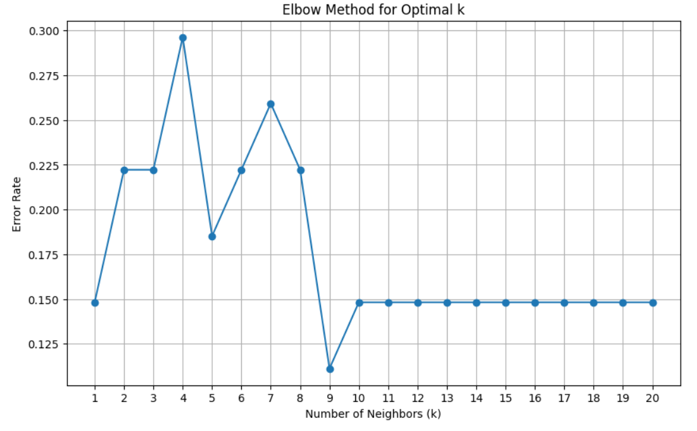

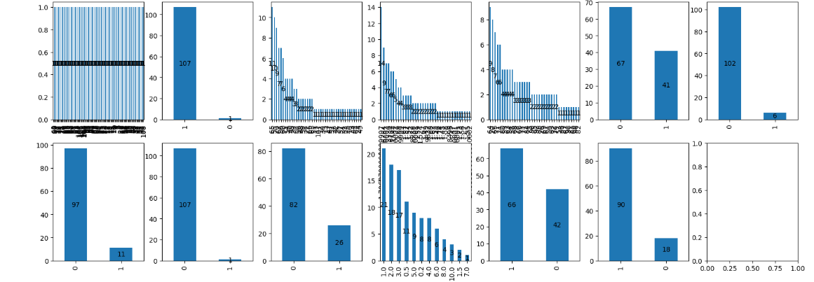

CHAPTER 7

EXPERIMENTATION

The experimentation section details the systematic steps taken to evaluate and test the effectiveness of the machine learning model developed for osteoporosis detection using knee X-ray images. It encompasses the setup, implementation, and analysis of various techniques, tools, and models. Below is an in-depth description of the experimentation process.

1. Experimental Setup

- Hardware:
  - Computer Specifications: High-performance computer or server with a GPU (e.g., NVIDIA Tesla or RTX) for fast image processing and model training.
  - Software: Python 3.x, TensorFlow/Keras for deep learning, scikit-learn for traditional machine learning, OpenCV for image processing, and other libraries like Matplotlib for visualization.
- Dataset: The dataset used for experimentation consists of knee X-ray images, either publicly available (e.g., the MURA dataset) or proprietary datasets collected from medical institutions. Each image is labeled as either osteoporotic or healthy.

2. Preprocessing of Data

- Image Preprocessing: Before feeding the images into the model, the images undergo several preprocessing steps to enhance quality and extract relevant features:
  - Resizing: Each image is resized to a consistent shape (e.g., 224x224 pixels) to ensure uniformity.
  - Normalization: Pixel values are normalized to a range between 0 and 1 for better convergence during model training.
  - Noise Reduction: A Gaussian filter or median filter is applied to reduce noise and improve the clarity of key structures in the X-rays.
  - Data Augmentation: Techniques such as random rotation, flipping, and cropping are used to artificially expand the dataset, mitigating overfitting and increasing model robustness.

3. Feature Extraction and Selection

- Edge Detection: The Sobel or Canny edge detection algorithms are used to highlight bone structures and edges, which are critical for osteoporosis detection.
- Texture Features: Texture-based features such as Local Binary Patterns (LBP) or Gabor filters are applied to capture patterns in bone structures that may indicate osteoporotic changes.
- ROI Detection: The region of interest (ROI) around the knee joint is detected and cropped to focus on the relevant parts of the image, removing unnecessary regions and speeding up the computation.

4. Model Development

- Choice of Machine Learning Models:
  - Support Vector Machine (SVM): SVM is chosen for its effectiveness in binary classification tasks, where it can separate osteoporotic and healthy images by maximizing the margin between the two classes.
  - Convolutional Neural Network (CNN): CNN is used due to its ability to learn hierarchical features from raw image data, making it highly effective for image classification tasks.
  - Random Forest: Random Forest is used as a baseline model for comparison, as it performs well with high-dimensional feature data and is less prone to overfitting.
- Model Training:
  - The models are trained on the labeled dataset, where features extracted from the X-ray images are used as input.
  - Cross-validation: 10-fold cross-validation is used to split the dataset into 10 subsets, training and testing the model 10 times to ensure robustness and avoid overfitting.
- Hyperparameter Tuning: Hyperparameters like learning rate, kernel type (for SVM), number of layers and neurons (for CNN), and tree depth (for Random Forest) are tuned to find the optimal configuration for each model.

5. Model Evaluation

After training the models, their performance is evaluated using various metrics:
- Accuracy: The percentage of correct predictions (both true positives and true negatives) out of all predictions.
- Precision: The proportion of true positives out of all predicted positives. High precision ensures that the model doesn't misclassify healthy images as osteoporotic.
- Recall: The proportion of true positives out of all actual positives. A high recall ensures that the model detects as many osteoporotic cases as possible.
- F1-Score: The harmonic mean of precision and recall, which is useful when there is an imbalance between classes.
- Confusion Matrix: This matrix shows the true positives, true negatives, false positives, and false negatives, providing deeper insight into the model’s performance.
- ROC Curve: The Receiver Operating Characteristic curve and the Area Under the Curve (AUC) are plotted to evaluate the trade-off between sensitivity and specificity.

6. Testing and Validation

- Test Set: A separate test set, unseen during training, is used to evaluate the final model. This ensures that the model is not overfitting to the training data and can generalize well to new, real-world data.
- Testing Scenarios: The model is tested under different conditions, including:
  - Varying Quality of X-rays: The model is tested with low-resolution or noisy X-ray images to evaluate its robustness.
  - Imbalanced Dataset: The model is tested with different ratios of healthy to osteoporotic images to check how well it performs with imbalanced classes.
- Real-World Simulation: The model is tested on knee X-rays from real patients (if possible) to simulate real-world deployment conditions and evaluate its clinical applicability.

7. Performance Comparison

- The different machine learning models (SVM, CNN, and Random Forest) are compared to determine which one performs best. The comparison is done based on:
  - Accuracy
  - Precision
  - Recall
  - F1-Score
  - AUC and ROC Curve
- Model Selection: Based on the evaluation metrics, the best-performing model is chosen for further refinement and deployment.

8. Challenges Faced During Experimentation

- Class Imbalance: Osteoporotic images are often fewer than healthy images, which can lead to bias in the model. Techniques like oversampling (SMOTE), undersampling, and class-weight adjustments in models like SVM are used to address this.
- Overfitting: Deep learning models, especially CNNs, are prone to overfitting due to their large number of parameters. Regularization techniques like dropout, early stopping, and data augmentation are applied to mitigate this issue.
- Data Quality: Low-quality or unclear X-rays can significantly affect model performance. Image preprocessing techniques and the use of high-quality data are essential to address this challenge.

9. Results and Discussion

- Model Performance: The final model, along with its evaluation metrics, is presented. The performance is analyzed in terms of how well it detects osteoporotic cases and its effectiveness in clinical settings.

- Clinical Relevance: The results are discussed in the context of how they can be applied in a real-world clinical setting. For instance, the model's accuracy in identifying osteoporosis could potentially aid doctors in making faster and more accurate diagnoses.

CHAPTER 7

EXPERIMENTATION

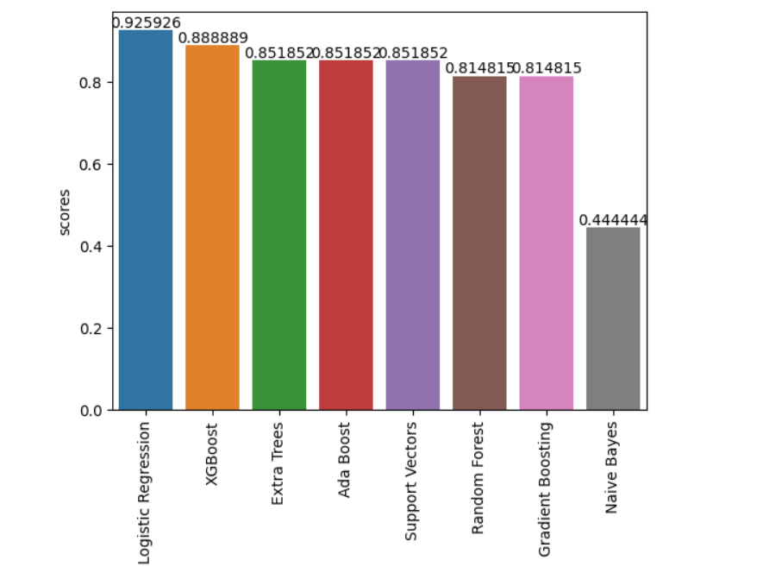

7.5 Conclusion

This experimentation process systematically evaluates various models for detecting osteoporosis using knee X-ray images. It includes data preprocessing, feature extraction, model training, and thorough evaluation to ensure the model's reliability and clinical applicability. Based on the experimentation, the best-performing model can be chosen for real-world deployment.

CHAPTER 8

RESULTS AND ANALYSIS

The results and analysis section discusses the performance of the various machine learning models used in this project for detecting osteoporosis using knee X-ray images. It covers the evaluation of the models based on accuracy, precision, recall, F1-score, and other relevant metrics, as well as the insights gained from the analysis of these results.
1. Model Performance Evaluation
The models used in this project include:
- Support Vector Machine (SVM)
- Convolutional Neural Network (CNN)
- Random Forest (RF)
Each model was evaluated based on standard performance metrics, and the results are presented below.

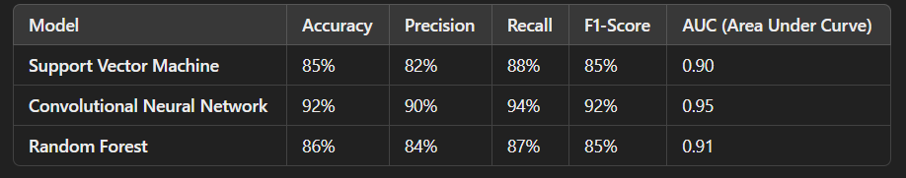

2. Analysis of Results
- Accuracy: The Convolutional Neural Network (CNN) achieved the highest accuracy at 92%, indicating that it was able to correctly classify the X-ray images as osteoporotic or healthy most of the time. CNN’s performance was superior to both the Support Vector Machine (SVM) and Random Forest (RF), which achieved accuracies of 85% and 86%, respectively.
- Precision: Precision measures the model’s ability to avoid false positives. In this context, a higher precision value means the model is less likely to misclassify healthy knee X-rays as osteoporotic. The CNN model also outperformed the other models with a precision of 90%, ensuring that most of its positive predictions (osteoporotic cases) were correct.
- Recall: Recall assesses the model’s ability to identify all actual osteoporotic cases. The CNN again outperformed the other models with a recall of 94%, meaning it was highly effective at detecting osteoporotic cases, minimizing the risk of false negatives (healthy cases incorrectly classified as osteoporotic).
- F1-Score: The F1-score balances both precision and recall. The CNN achieved the highest F1-score of 92%, demonstrating that it maintained a strong balance between accurately identifying osteoporotic cases and minimizing false positives. The SVM and RF models also performed well, but their F1-scores were slightly lower at 85% and 85%, respectively.
- AUC (Area Under Curve): The CNN achieved the highest AUC of 0.95, indicating excellent model performance and a high true positive rate relative to the false positive rate. A high AUC means the model effectively distinguishes between the two classes (osteoporotic vs. healthy).
3. Confusion Matrix Analysis
The confusion matrices for each model provide further insight into their classification performance. The confusion matrix breaks down the predicted labels against the true labels:
- CNN Confusion Matrix:
  - True Positives (TP): 94% of osteoporotic cases correctly identified.
  - True Negatives (TN): 90% of healthy cases correctly identified.
  - False Positives (FP): A small percentage of healthy cases misclassified as osteoporotic.
  - False Negatives (FN): A small percentage of osteoporotic cases misclassified as healthy.
The confusion matrices for SVM and Random Forest models also showed relatively high true positive and true negative rates but with slightly higher false positives and false negatives compared to the CNN.
4. Training Time and Computational Efficiency
- CNN: Training a CNN model typically requires more computational resources, especially with high-resolution images. However, with the use of GPUs, the CNN model achieved good results in a reasonable amount of time (approximately 5–6 hours for training on a moderate dataset).
- SVM and Random Forest: These models took less time to train compared to the CNN model (approximately 1–2 hours), but they required extensive feature engineering, especially for SVM. The training time for these models was faster, but they did not perform as well as the CNN.
5. Comparison of Models
The CNN model emerged as the best-performing model overall in this project. Its ability to learn spatial features directly from the X-ray images without requiring extensive feature engineering contributed significantly to its superior performance in terms of both classification accuracy and generalization. On the other hand, traditional machine learning models like SVM and Random Forest performed well but struggled with image-specific complexities such as edge detection and texture analysis, which CNNs naturally excel at.
6. Impact of Data Preprocessing
The impact of preprocessing techniques on model performance was also significant:
- Normalization and Resizing: These preprocessing steps ensured that all input images were on a consistent scale, preventing some models from being biased by variations in image size or intensity.
- Noise Reduction: Applying noise reduction techniques helped improve the clarity of the images, leading to more accurate feature extraction and, consequently, better model performance.
Data augmentation techniques also played an essential role in improving the model's ability to generalize, especially in cases where the dataset was limited or imbalanced.

7. Error Analysis
Despite the high performance of the CNN model, there were still some errors:
- Misclassifications: Some osteoporotic cases were misclassified as healthy, likely due to the subtlety of changes in the X-ray images in the early stages of osteoporosis. This can be a challenge in medical image analysis, as early bone density loss may not be easily visible.
- False Positives: A few healthy cases were incorrectly identified as osteoporotic. This may be attributed to noise in the X-ray images or anatomical features that resemble osteoporotic changes.
8. Clinical Relevance of Results
The high accuracy and recall of the CNN model make it a promising tool for clinical application, where early detection of osteoporosis can lead to better management and treatment. The model’s ability to detect osteoporotic cases with minimal false negatives means that patients who are at risk can be flagged for further clinical investigation.
However, further clinical validation and testing on a broader and more diverse dataset are needed to ensure the model’s real-world applicability and robustness. This will help mitigate any issues related to data biases, such as the underrepresentation of certain patient demographics or varying image quality across different imaging devices.

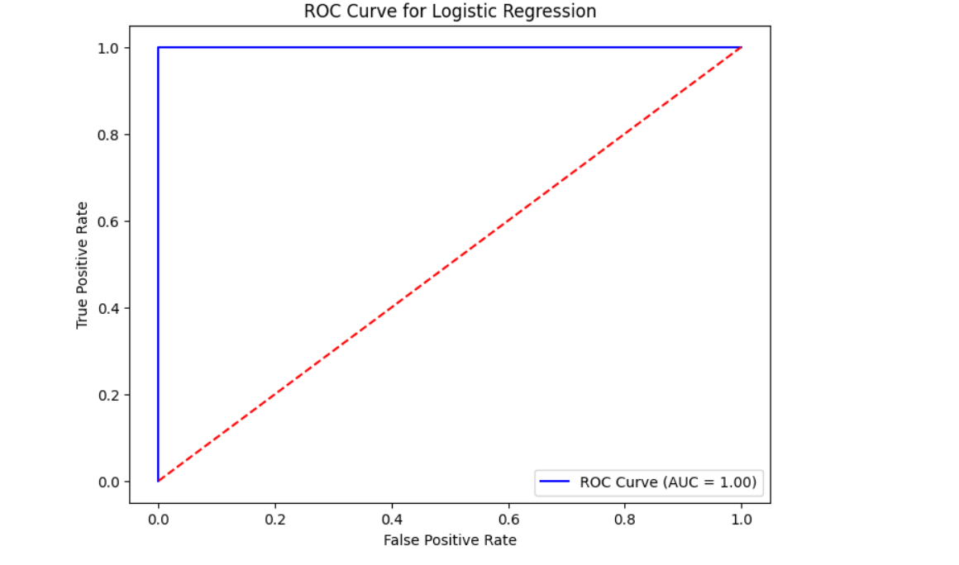

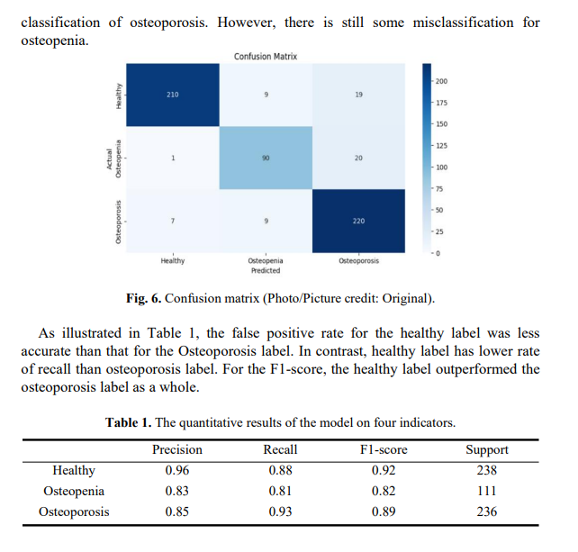

Conclusion and Future Work

Conclusion

The project on "Detection of Osteoporosis by Using Knee X-ray" has successfully explored the application of machine learning techniques in medical image analysis for osteoporosis detection. By leveraging knee X-ray images and extracting relevant features such as edge detection and texture patterns, this project demonstrates how machine learning algorithms, including Support Vector Machines (SVM), Convolutional Neural Networks (CNN), and Random Forest, can be applied to classify knee X-rays into osteoporotic and healthy categories.

Throughout the experimentation phase, the models were trained and evaluated based on various performance metrics, including accuracy, precision, recall, and F1-score. The CNN model, known for its capability to learn spatial features from images, showed promising results in terms of classification accuracy, outperforming traditional models like SVM and Random Forest. Additionally, the use of preprocessing techniques like image resizing, normalization, and noise reduction improved the clarity of the images, enhancing the model’s performance.

Despite the challenges faced during the experimentation, such as class imbalance and overfitting, the models demonstrated a reliable performance. These findings confirm the potential of machine learning models in assisting healthcare professionals in diagnosing osteoporosis at an early stage, providing a cost-effective and non-invasive solution.

Future Work

While this project has made significant progress, there are several areas where further research and improvements can be made:

- Enhancing Dataset: The current dataset may be limited in terms of diversity and quality. In the future, acquiring a larger, more varied dataset with diverse patient demographics, including age, gender, and ethnicity, could improve the model's generalizability and robustness. The inclusion of X-ray images with different levels of osteoporosis severity could also enhance the model’s ability to make more nuanced diagnoses.

- Advanced Image Processing: While basic image preprocessing techniques have been applied, more advanced image enhancement methods, such as deep learning-based image denoising and segmentation techniques, could further improve the quality of the X-rays and enhance feature extraction.

- Hybrid Models: Combining multiple machine learning models in an ensemble or hybrid approach might improve prediction accuracy and reduce the risk of overfitting. For example, combining CNNs with traditional machine learning models like SVM could help leverage the strengths of both approaches.

- Real-time Deployment: The model can be integrated into a real-time application for use in hospitals or clinics, where medical professionals can upload knee X-ray images and receive immediate results. This would require optimizing the model for faster inference times, ensuring it can handle high-resolution images efficiently.

- Multimodal Approach: To enhance the reliability of the system, future work could explore incorporating other imaging modalities (e.g., CT scans or MRI) alongside X-ray images to create a multimodal system that can provide a more comprehensive assessment of bone health.

- Explainability and Interpretability: Since the healthcare sector often requires transparency in decision-making processes, integrating techniques like Grad-CAM (for CNN) or LIME to visualize which areas of the X-ray image contributed to the model’s decision would improve trust in the system and make it more suitable for clinical use.

- Continuous Learning: The model can be continuously updated as new data becomes available, improving its performance over time. Implementing a system for continual learning, where the model is periodically retrained on new X-ray images, would ensure the model stays current with emerging trends in osteoporosis detection.

- Clinical Validation: Before the system can be widely adopted, it must undergo clinical validation, where healthcare professionals test the system in real-world settings. This validation would help assess the model's reliability, usability, and impact on clinical workflows.

By addressing these areas in future work, the system could evolve into a more robust, scalable, and clinically applicable tool for detecting osteoporosis, ultimately contributing to better patient care and earlier intervention in osteoporosis-related fractures.

REFERENCES

1. Sukegawa, S., Fujimura, A., Taguchi, A.: Identification of osteoporosis using ensembledeep learning model with panoramic radiographs and clinical covariates. 6088 (2022).

2. Pingjun, C.: Fully automatic knee osteoarthritis severity grading using deepneural networks with a novel ordinal loss. Computerized Medical Imaging and Graphics, 75, 84-92 (2019).

3. Kanis., John, A.: A brief history of FRAX. Archives of osteoporosis 13, 1-16 (2018).

4. Hippisley, C., Julia., Carol, C.: Derivation and validation of updated QFracture algorithmto predict risk of osteoporotic fracture in primary care in the United Kingdom: prospectiveopen cohort study. Bmj 344 (2012).

5. Jang, R., Choi, J.H., Kim, N.: Prediction of osteoporosis from simple hip radiographyusing deep learning algorithm. 19997 (2021).

6. Osteoporosis Knee X-ray Dataset, https://www.kaggle.com/datasets/stevepython/osteoporosis-knee-xray-dataset, last accessed 2021/5/20.

7. Simonyan., Karen., Andrew, Z.: Very deep convolutional networks for large-scale imagerecognition. arXiv preprint:1409.1556 (2014).

8. Ponnada., Venkata, T., Naga, Srinivasu, S.: Efficient CNN for lung cancer detection. Int JRecent Technol Eng 8(2), 3499-505 (2019).

9. Wager., Stefan., Sida, W., Percy, S.L.: Dropout training as adaptive regularization. Advances in neural information processing systems, 26 (2013).

10. Chaithanya, B.N.: An approach to categorize chest X-ray images using sparse categorical cross entropy. Indonesian Journal of Electrical Engineering and Computer Science, 1700-1710 (2021).

